SAVE the DATE


BINGO

Saturday, February 20th, 2027
Yadkinville United Methodist Church
Doors Open at 5:00 p.m.
Activities Begin at 6:00 p.m.
Proceeds Benefit:
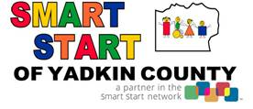

For questions or to pre-order packets,
Call the Smart Start office at 336-677-1125

Financial information about this organization and a copy of their license is available from the
State Solicitation Licensing Branch at 919-807-2214. The license is not an endorsement by the State.

